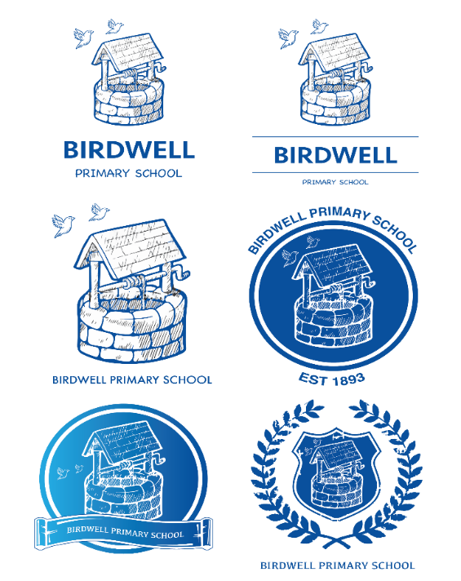

What is your favourite lesson?

**Divinity.**

What are the stars and where is the Earth in space? Why do we have night and day. (Science)

**Potions**

What happens when we combine different materials. Can changes be reversed? How can we do it? Are any new materials made from combining different potions.?(Science)

**Spells**

Create a spell of your own using Latin root words (Literacy)

**Defence Against the Dark Arts**

Physical fitness and agility will help you survive a duel with a dark wizard!

**Quidditch**

Team games and skills training (PE)

**Muggle Studies**

How do silly old Muggles achieve anything without magic? (Science)

Are you ready for School?

**The Hogwarts Letter**

Reading comprehension & letter writing a reply. (Literacy)

Where exactly is Hogwarts?(Geography)

**Shopping at Diagon Alley**

What products would you buy for your money? (Maths)

Can you design a new shop that the alley needs?

**Platform 9 ¾**

Using a timetable to work out journey times and fastest routes. (Maths)

**The Sorting Hat**

What are your personal qualities? Strengths, weaknesses? (PSHE)

**The New Teacher**

Every year at Hogwarts, a new teacher appears on the scene to teach Defence against the Dark arts. Who will it be this year? (Art, Literacy)

Could you survive

a term at Hogwarts?

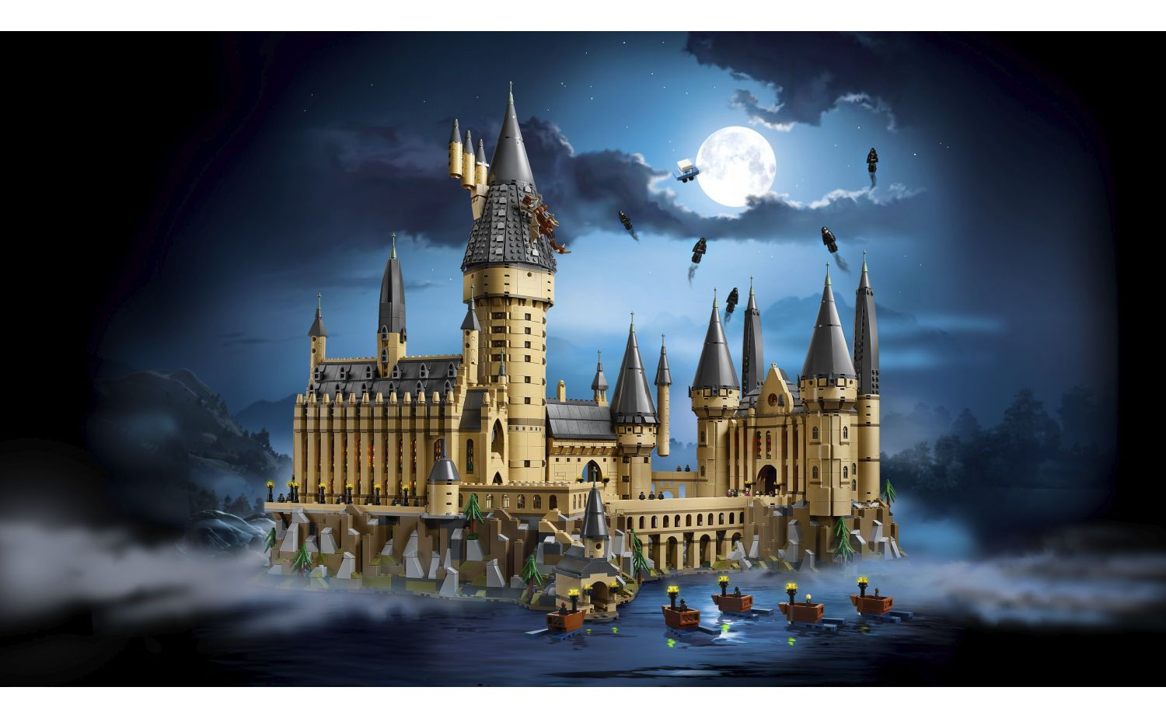



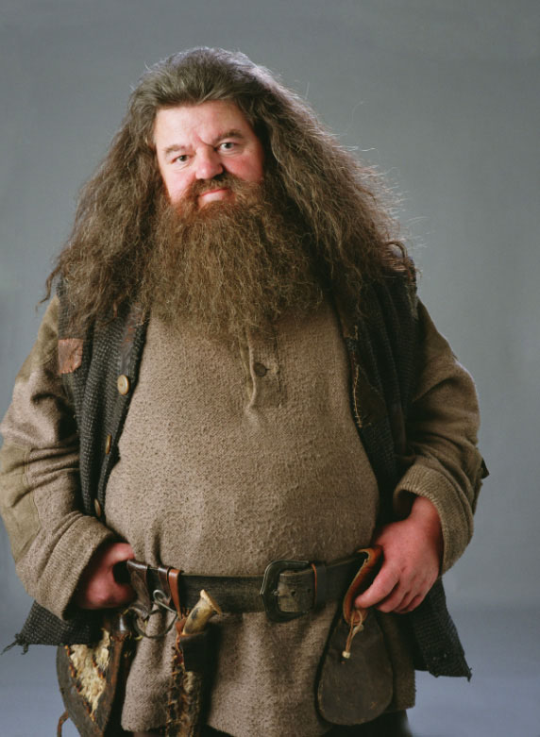

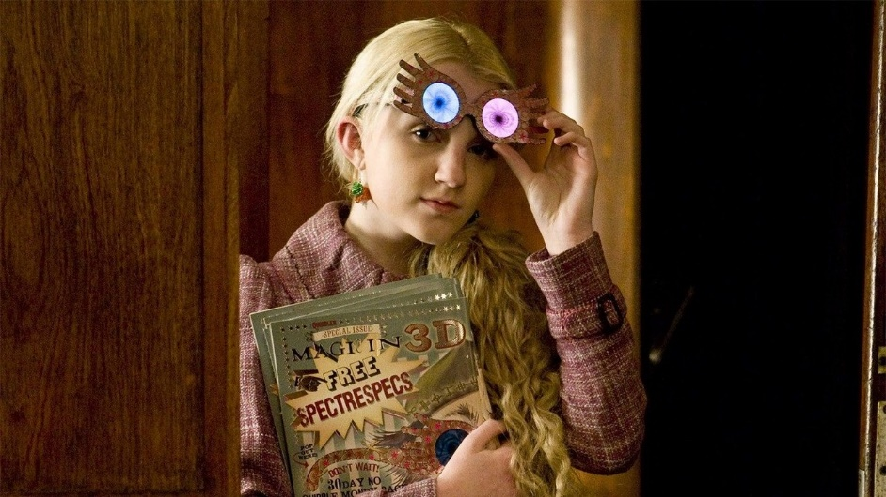

You are invited to the Annual

Hogwarts Summertime ball

**What will you wear?**

Year Group: Year 5 Mr Swallow Term: Summer 2